**Unit 14 Games Task A: investigate technologies used in computer gaming.**

**Mohammed Mahin Ibnay Mamun (346584)**

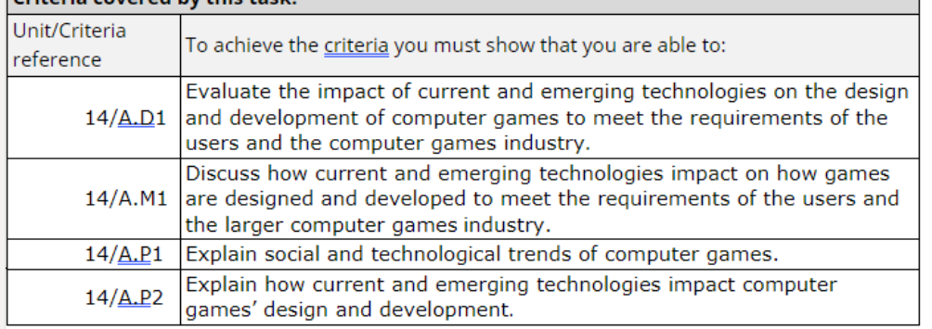

**Impact of current and emerging technologies**

Due to technology constantly advancing, our daily lives are being affected in multiple ways. A huge area where this can be seen is in the gaming industry. Current technology has affected the gaming industry in recent years. By doing this, video games all over the world have become more fun, engaging, and challenging. There are multiple ways this has been accomplished for example via the upgrade of: processor power, graphics card, AI (Artificial Intelligence), VR, internet, and social gaming.

**Processor power**

**(p1&p2)**

**What is processor power?**

The processor power can also be defined as CPU power. In a computer, the processor power is the potential to utilize data. Key factors of processor power are processor power cannot be stored nor is it fixed. By fixed we mean it can only be run at its set power. Processor power cannot store any data for later. The consumers of the processor power are the OS and applications.

**How is processor power used and what is the effect? (Social trends)**

Processor power is heavily used in our daily video games. However, this is not the only way to improve gaming, there are many other things which you can do such as upgrading your graphics card and optimizing your OS. The benefit of getting better (more powerful) processor power will result in gameplay being smooth. Having more processor power allows your gameplay to increase FPS which are your frames per seconds allowing a smooth gameplay. This can also allow the game design to look a bit clearer when moving around due to fewer delays, which is wanted by most if not all users. The benefit which the user receives is a better detailed and smoother processing game.

**(M1 & D1)**

**How does this change gaming?**

The images below show what the difference looks in a game for the users when they play with a lower processor speed vs higher. This can be accomplished by upgrading your CPU to a faster processor.

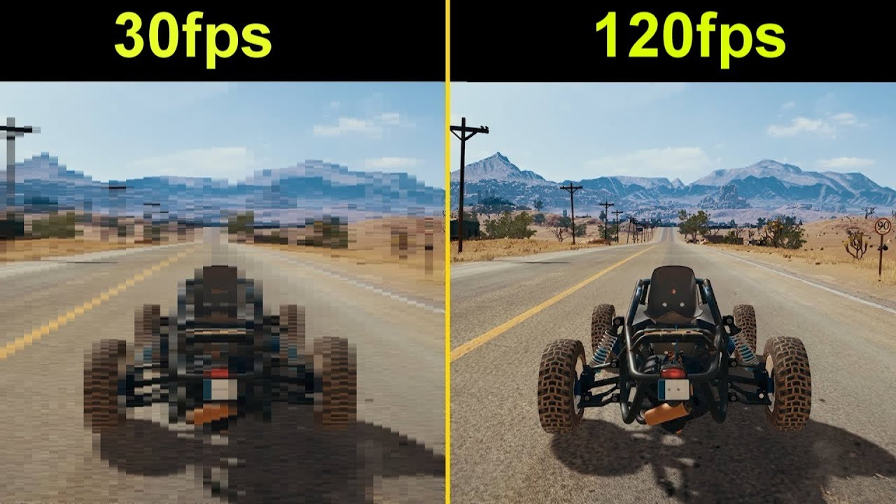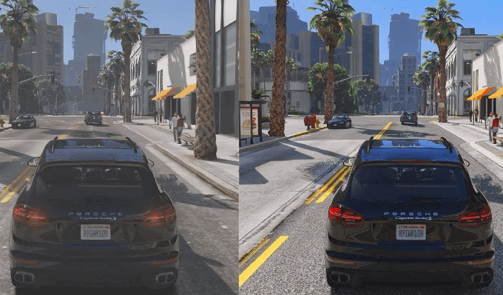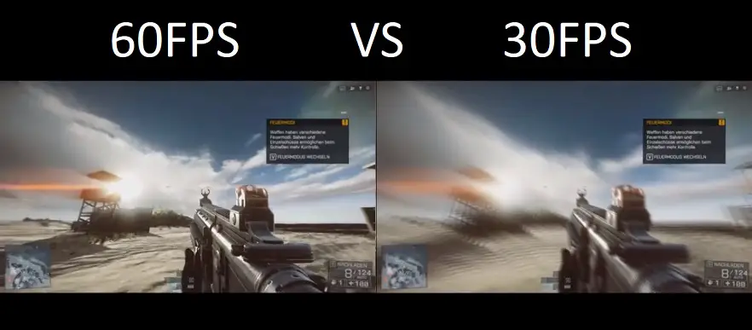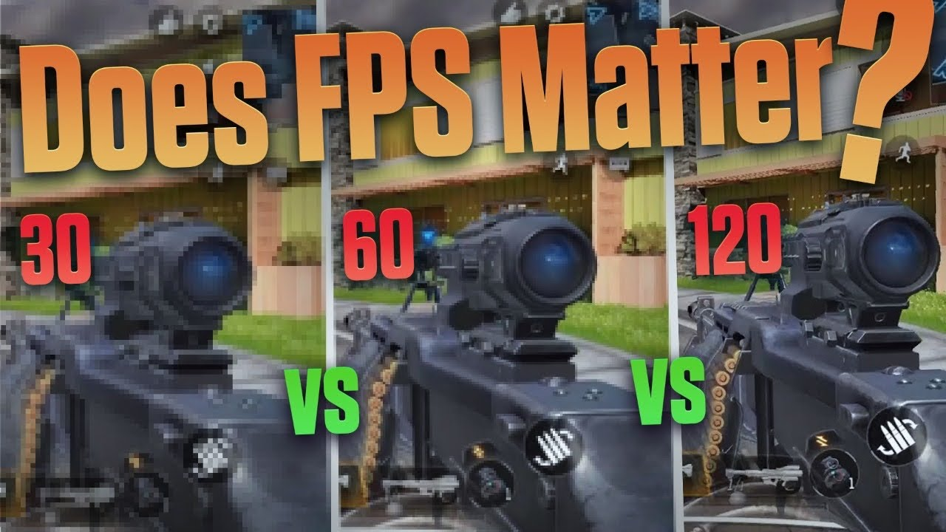

A processor which has a greater clock speed is highly wanted by gamers. The result of this will allow users to play the latest games. This works because a pc with more clock speed can run more calculations in a few seconds. The benefit this has for gamers is demand, this allows them to engage more in a game when they first release. This can be reached through high clock speed.

**Benefits of processor power for gamers and developers / gaming industry**

When gamers install better processors power for their gaming devices, they get a better visual game experience which allows them to enjoy the game more

Overall, the benefits of increasing processor power in gaming are:

* Reduce lag and latency
* Increase Frames Per Second (fps)
* Smoother gameplay
* Instructions get send to pc faster
* Better graphics / more realistic gameplay / better texture

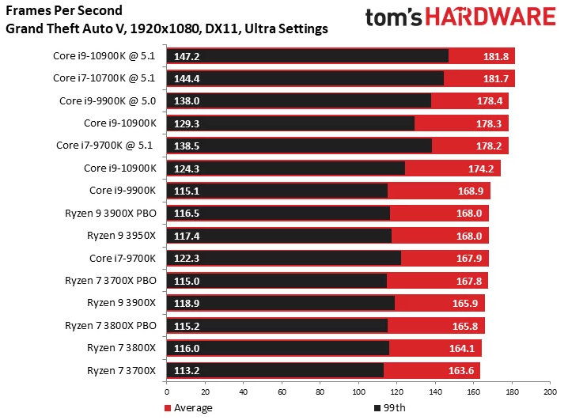

(Source: [Best CPUs/Processors for Your Gaming PC in 2023 - TechEngage](https://techengage.com/best-gaming-processors-cpus/) )

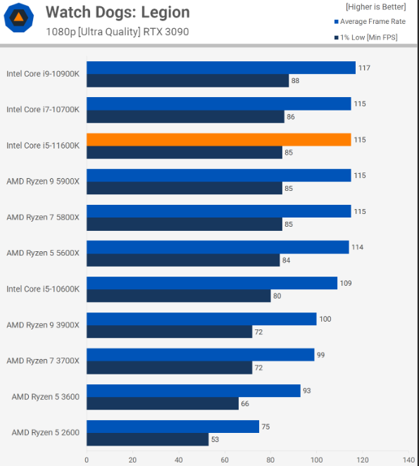

(Source: https://static.techspot.com/articles-info/2220/bench/WDL.png)

Above are 2 charts from 2 different games which show you the frames per second received according to the processor power of the CPU used. These graphs are also not outdated as they have only been released over the last year.

**Graphics Card**

**(p1&p2)**

**What is a graphics card**

High-quality graphic images are produced on a screen by a microprocessor called a GPU. The GPU, also known as the graphics processing unit, is called the graphics card. The graphics card is a printed circuit board, much like the motherboard in your computer. It comes with a specific set of directions to follow. Moreover, it includes fans, onboard RAM, a dedicated memory controller, BIOS (basic input output system) and other features.

There are 2 main types of graphics cards. One is the intergraded GPU and the other is the dedicated GPU. A motherboard-integrated GPU is cheaper than a separate graphics card. It is appropriate for general graphics processing, including watching or editing videos, as it requires less energy and produces less heat. On the other hand, A dedicated GPU is put on a different graphics card and has its own visual memory. Graphic designers and competitive gamers use these because they offer the top visual quality, however they use more energy and produce more heat than an integrated GPU.

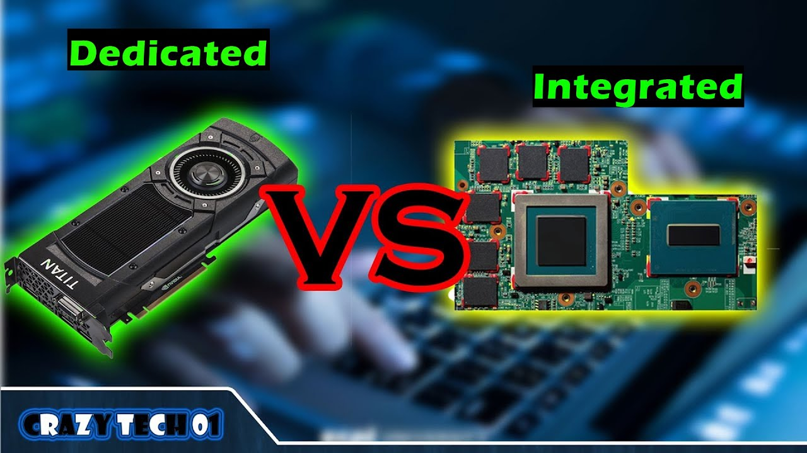

**How does a graphics card affect gaming and change the way we play?**

Having a good graphic card can affect the overall playstyle of gamers. One key factor is that having a better graphics card can produce a faster game speed Aswell as higher frame rate. It is proven that having a better graphics card allows you to play with improved textures. With a greater

Due to technological advancement, a graphics card is required to access video games. As there are many unusual types and models available, a lot of developers now include in their games the recommended and minimum graphics card required for the game. This is a good feature for the gamers as it will give them a good allocation whether they will be able to run the game smoothly.

**(M1 & D1)**

**What is the effect on the gaming industry and developers**

When gamers upgrade to a better graphics card, this allows them to run better gameplay and new up to date graphics. This put working developers at an advantage because the gamers will get to play their games when it releases at first and when the latest updates are released. Having more players when a new update is released can be seen as a huge advantage for developers as it spikes the growth of gamers on that game. For example, if a video game streamer decides to live stream or upload videos of the new update or new games it causes more attention towards it. This allows developers to benefit from a spike of users playing. There may also be items limited in game due to certain events or seasons, this can have an influence on viewers of gamers and allow them to purchase Aswell as the gaming streamers which in result makes more money for developers and the gaming industry.

**How does graphics cards change gaming**

* Performance increase in speed
* Increase of graphics in games
* Video graphics are displayed better
* Greater driver support

When you play a video game with the following features listed above, you see a drastic overall gaming improvement.

**Artificial intelligence**

**(p1&p2)**

**What is Artificial intelligence**

Ai is a shortened form of Artificial intelligence. The understanding behind this concept is a computer which performs in a humanly fashion. Over the years, Artificial intelligence has become more popular in our daily lives, for example: self-checkout machines at a store uses AI to work like humans to perform a certain task. However, a wide area which Ai has impacted is video games.

**How is Artificial intelligence used and what is the effect? (Social trends)**

The most common source of artificial intelligence seen in gaming is by npc’s and bots. When you join an online game, we can see these characteristics. For example, if you join an online shooter game, we can spot bots. This is seen when an enemy in front of you is delaying their reflex or missing all their shots. This is the most common way to identify a bot. Another way gamers can identify bots is via the leaderboard system. Some games may display bot tags near the names of an Artificial intelligence opponent. In other cases, you can check the leaderboard for any unusual, automated names or stats. For example, rank 1.



A lot of games which we play now a days consists of NPC. This abbreviation stands for non-playable characters. This is also a type of AI added to many worldwide games. For example, this can be seen in games which have a tutorial or story mode. The tutorial will highlight an NPC character who you as the gamer cannot control but you can interact with to help you with game tips and advice to get past the game.

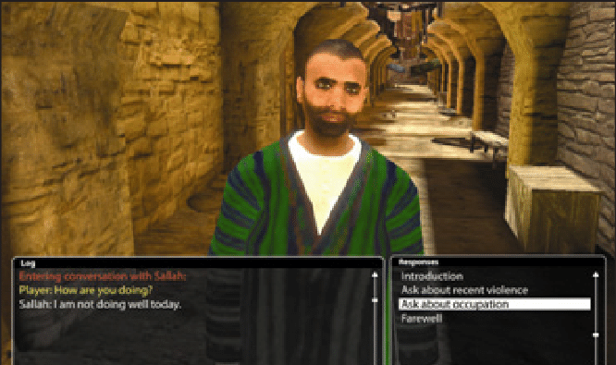

**(M1 & D1)**

**How has ai changed the way we play**

At one time, video games were simple to complete if the user can defeat the algorithm. However, due to Technoloy advancing this makes it more challenging for users to defeat games as Ai can be seen as an enemy or a barrier in games.

The use of Ai added to video games can be seen as a benefit for the video game industry and developers. The reason for this is because, console games Aswell as handheld devices are experiencing a more engaging approach to their games.

Thank to having NPC added video games, this makes the game extremely helpful for unpracticed players to the game genre or game itself. For example, if somebody always played puzzle games and decided to try a shooter game, they can enter a training area where an NPC will teach them the basic controls. This can be seen in other games not just shooters, another example is FIFA. They use NPC players to practice against in the practice arena.

**What is the effect on the gaming industry and developers**

An enormous impact which Artificial intelligence has on gaming is that it allows you to keep on playing video games. You will never join a game with no teammates or opponents due to artificial intelligence. There will always be others, either bots or real players in the game to play with and against. The benefits this has on the developers is, it allows them to keep generating money from their gamers.

**Virtual reality**

**(p1&p2)**

**What is virtual reality**

Virtual reality, also known as VR, is a 3d computer generated simulation. VR will display an image, but it is more common to display an area of environment. As humans we can purchase a VR kit which consists of a head set piece and hand pieces which act like paddles or gloves. Once a human places the headpiece and turns it on, they will be able to interact with the environment and objects shown on the VR.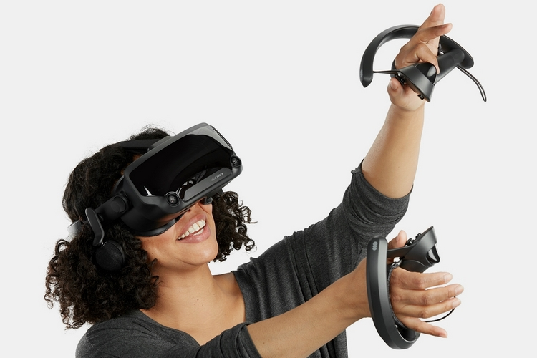

**How is virtual reality used and what is the effect? (Social trends)**

With access to virtual reality, video games are seen as a more engaging experience. Users are more likely to enjoy the games in this style of gaming as it is different from many others. When playing in VR, the game graphics are displayed through the head piece above the human eyes. As VR has been a well-spoken subject for a while it is beginning to get more popular nowadays with the emergence of technology.

**(M1 & D1)**

**How does this change gaming?**

VR causes a change in gaming, the reason for this is because if VR manages to get increasingly popular, more gamers will make it in demand. This means that old consoles and other games will not be played by anyone or played less.

**What is the effect on the gaming industry and developers**

To play a virtual reality game, a VR kit is required. This can be purchased online or at many stores. The more popular VR becomes, the more VR kits will need to be manufactured and sold out at stores. As this can be seen as a benefit for the gaming industry, it may cause a drawback for the developers themselves.

Developers will now need to be able to create video games which are compatible with VR. As well as putting in a lot of time to create and design the game, a lot of time will also be put into the testing.

**Mobile devices**

**(p1&p2)**

**What is a mobile phone**

The ability to place and receive calls is provided by a mobile phone, which is a wireless handheld device. The early mobile phones could only make and receive calls, but modern mobile phones can access web browsers, games, cameras, video players, and navigational systems, and other things.

**How is a mobile phone used and what is the effect? (Social trends)**

During the early years, having a mobile phone was seen as uncommon. Not very many people had one or access to one. The main feature of owning a mobile phone was to create calls and send text messages. There was not much more to do on a mobile phone during the initial stages of development.

As mobile phones have been around for a while, they have made a lot of improvements to their devices, mobile phones are now known for the other features which they share and one of these features is for gaming. We started off playing snake and sudoku on mobile phones but now we have access to over thousands of games available to download from different genres. As shown in recent studies, mobile gamers have increased hugely over the past years.

**(M1 & D1)**

**How do mobile phones change gaming?**

Due to access of gaming on mobile phones, an increased gamers are actively playing games. For example, many gamers can go to a library and play games on their phones. Another example can be when gamers meet with their friends, they can all join on a video game from their phone. This lets more players engage in games and play more. It also lets them play games in a distinctive style against a distinct experience of players. Gaming on mobile phones is becoming more popular now since mobile phones are portable. Another reason more gamers are playing on mobile phones is because it costs a lot less compared to buying a pc. This is a benefit highly towards the younger generation of gamers who may not be able to afford pcs.

**What is the effect on the gaming industry and developers**

By giving access to humans via mobile phones, the gaming industry still benefits from gamers. The reason for this is because most mobile games have ads and in game purchases which allows the gaming industry to benefit from. As users are frequently active on mobile phones, it allows gamers to still enjoy playing video games wherever they are.

**Internet speed and bandwidth**

**(p1&p2)**

**What is internet speed and bandwidth**

The total quantity of data you can download or upload in a second is how fast a connection is. Depending on your internet plan and the type of connection, your bandwidth is the total amount of data you are permitted to download or upload in a single second. Internet speed and bandwidth both affect the download of your games and the updates Aswell as running the initial gameplay. It is also crucial to most online games as without it, you will not be able to access the online side.

**How is internet speed and bandwidth used and what is the effect? (Social trends)**

In the early games, when games were released, they were released in one full version. Due to internet and bandwidth which we can benefit from these days, we can see a more engaging side to games via updates. Wheather they are seasonal updates or easter egg updates. If games did not have updates, there would always be a simple ending and games would refer to gaming being repetitive. Having low internet speed and bandwidth can allow gamers to experience high ping and data packet loss which also puts the user at a disadvantage.

**(M1 & D1)**

**How does internet speed and bandwidth change gaming?**

This makes games better for the users as it allows better speed gameplay with fewer input delays and lag, which can be seen as a disadvantage. This makes gaming a lot better with more to do in a single game. Having a better internet speed and bandwidth allows you to run games which take up more processing speed at a better rate compared to running at a lower speed.

**What is the effect on the gaming industry and developers**

When faster internet speed and bandwidths are released to the public, the gaming industry can release more content for their audiences. This allows the gaming industry and developers to take in more profit from the game due to in game purchases. It also allows streamers to live stream and upload added content when it is first released due to having a faster download and upload speed.

**Social connectivity**

**(p1&p2)**

**What is social connectivity**

Social connectivity is the term in gaming used to describe when users are communicating with others and playing with others. Social connectivity comes with a lot of benefits, for example it makes the games more engaging and allows friends to work together.

**How is social connectivity used and what is the effect? (Social trends)**

A big aspect to social connectivity is that it allows gamers to communicate with each other. There are 2 ways this can be seen, for example you can communicate for entertainment if you are bored, or you can also use communication to your advantage when playing games to help work together to complete the game or get a victory.

**(M1 & D1)**

**How does this change gaming?**

In the early generation of gaming, all games were only 1 player and played against a bot or computer. Ever since social connectivity was released, a large amount of user's games now allows connectivity and access for others to join to make games more fun. Having access to social connectivity, gamers can impact and benefit from playing online with friends and other online gamers across the world. You can simply plug in a headset and use a microphone to speak to your friends or teammates.

**What is the effect on the gaming industry and developers**

The gaming industry and developers of games benefit from their gamers playing games using social connectivity. The reason for this is it allows the audiences to spend more time on their games which will help the developers generate money. It also allows developers to keep in mind that making games which are multiplayer should be created as many people will enjoy playing with their friends.